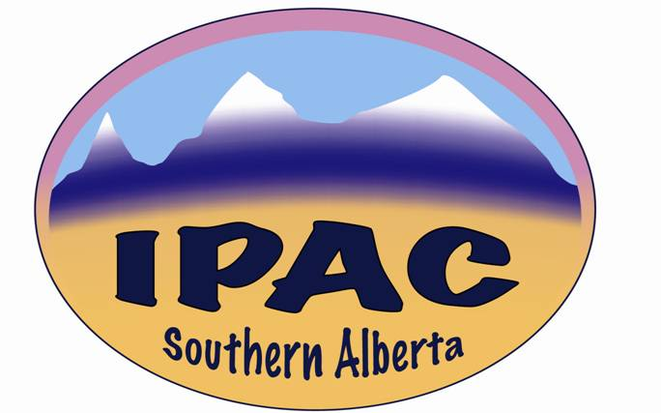

**GENERAL MEETING**

**Minutes**

Date: October 6, 2021 Time: 1300 – 1400 Venue: via Lync

**Attendees**

Kim Houde, Joseph Kaunda, Jason Morris, Andrew Lum, Ashley Shackleford, Dione Kolodka, Gaye Sydenham, Gord Platt, Heidi O’Grady, Jacinda Sartison, Jennifer Ellison, Jennifer Mcmullen, Khaled Altabtbaei, Kat Linton, Kristin Cannon, Lori Stuber, Lynn Curry, Olga Fernandes, Rhonda Demarco, Sandra Bolton, Sandra Dunbar, Suzanne Gavet, Shanthi Anchan, Tim Clifford, Zaheeda Jessani, C Frank (on phone), Melody Cordoviz – (Guest Speaker).

**Apologies**

Jennifer Happe, Craig Pierce

The President, Kim Houde, called the meeting to order at 1300 hr.

**Education**

The President introduced day’s speaker, Melody Cordoviz from AHS Edmonton Zone. Education topic: *IPC Novel Coronavirus and Vulnerable Population – Edmonton Expo Centre.*

**Business**

President’s Report – Kim Houde

President requested that anyone interested in participating in the IPAC-SA executive please submit their names for elections that we hope to hold in December. Most roles are up for new candidates:

President

President-elect

Treasurer

Web Master

Seminar/Fund-raising coordinator – vacant

Members are asked to submit their names for election and voting at the December meeting.

Secretary’s Report – Joseph Kaunda

No update

Treasurer’s Report – Kristine Cannon

There was no meeting in 2020 because of the Covid pandemic

The chapter started 2021 with a balance of $13,609.

So far, there has been limited spending, other than the approx. $800 that was spent on sponsoring two attendees to the IPAC-CA 2021 conference.

$1900 was received from IPAC-CA

Account standing is approximately $15,000.

Book auditing to be done soon.

The treasurer noted that the chapter should not be having so much money as we are a non-profit organization.

Ideas on possible expenditure avenues were floated. These included:

1. Sponsorship to educational conferences and seminars (IPAC and non-IPAC)
2. Holding expos with industry partners, to showcase “what is new.” This could coincide with any proposed education day. The discussion remains open.

In the absence of further items for discussion, Jason called off the meeting at 1358 hr (The President was having connectivity issues).

**Interest Groups Updates** – submitted pre/post-meeting

Surveillance and Epi (SAEIG)

Jennifer Happe

*SAEIG has partnered with the LTCIG again to commence review of the literature for evidence based updates to the LTC surveillance definitions. Final case definitions will be published in CJIC in late 2022.*

Environmental Hygiene IG

Gord Platt

*As promised, this interest group met Sept. 15...(the previous EHIG meeting was January 2020) always a very well attended meeting with the largest number of participants for IPAC interest groups.*

*1.  Natalie Bruce, Secretary term is up at the end of year, so they are looking for a new Secretary to take over from her 6 year tenure.*

*2.  Barry Hunt, Chair term is up end of year, so they are looking for a Chair for the next 2 years.  Monica Stanton is Vice Chair.*

*Open forum discussion...talked about challenges which included supply chain issues that occurred via industry.  Also summarized previous presentations from the past meetings prior to COVID.*

*Next meeting is November 2021 (details TBD)...discussion topic will be on Airborne concerns with COVID.*

Construction IG

Joseph Kaunda

*We have had a couple of meetings. A sub-committee has been constituted to work on gathering and sending feedback to CSA for the upcoming review of CSA Z8000-18. At the most recent meeting, an air dynamics engineer from Toronto gave an in-depth talk on aerosols and filters; and made a strong argument for the potential of some airborne transmission of Covid-19.*

Next meeting: December 1, 2021 at 1300 hr.